**Title:** Displaying Geospatial Data

**What you will learn:**

* Organize map layers
* Set the project Coordinate Reference System (CRS)
* Symbolize map layers
* Compose a basic print layout

**Resources:**

* Data for this exercise is in the data4 folder (**UNZIP** the folder after downloading).
* Projection system in QGIS <https://docs.qgis.org/3.34/en/docs/user_manual/working_with_projections/working_with_projections.html>

**Laboratory Exercise:**

In this exercise, you will learn to complete a well-designed map showing the relationship between species (Sage-grouse) habitat and federal land ownership. You were contacted by a wildlife biologist who is writing a paper on the state of Sage-grouse populations in the western US. She needs a letter-sized, colored, map that shows the relationship between the currently occupied sage-grouse habitat and federal land ownership. She wants to see how much habitat is under federal vs non-federal ownership. You have been provided data from the US Fish and Wildlife Service depicting the currently occupied range for sage-grouse, state boundaries, country boundaries, and federal land ownership. The land ownership data has an attribute column describing which federal agency manages the land (AGBUR). She wants to see the habitat shown so that the federal land ownership is visible beneath. Also, the different federal land managers should be distinguishable on the map.

**Deliverables:**

* Lab report
* Final map (image inserted in the lab report and pdf submitted with the report)

**Procedure:**

***Part 1 – Add data and organize map layers.***

1. Open QGIS 3.x and make sure that the *Browser Panel* is open

2. In the Browser Panel, navigate to the folder data4 (make sure that the folder is unzipped!)

3. You will see 5 shapefiles in the data folder:

* Canada.shp
* Land_ownership.shp
* Mexico.shp
* Sage_grouse_surrent_distribution.shp
* States.shp

4. You can select them all by holding the Ctrl key on the keyboard while left-clicking each shapefile (Figure 1).

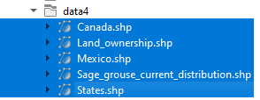

Figure . Selected shapefiles

5. Drag the five selected shapefiles onto the *Map Canvas* (aka Map View)area.

You can also right-click on these layers and choose *Add Selected Layers to Project.* You can also just double-click on each layer to add them individually.

You might be asked to “Select Transformation” for Sage_grouse_current_distribution and Mexico, just click OK on all questions regarding transformation. QGIS should look like Figure 2 a or b regardless of the color. Note: If you do not see anything displayed, you may need to zoom to the full extent of the map by clicking *Zoom Full * button. You can also click *View* – *Zoom Full* from the menu bar.

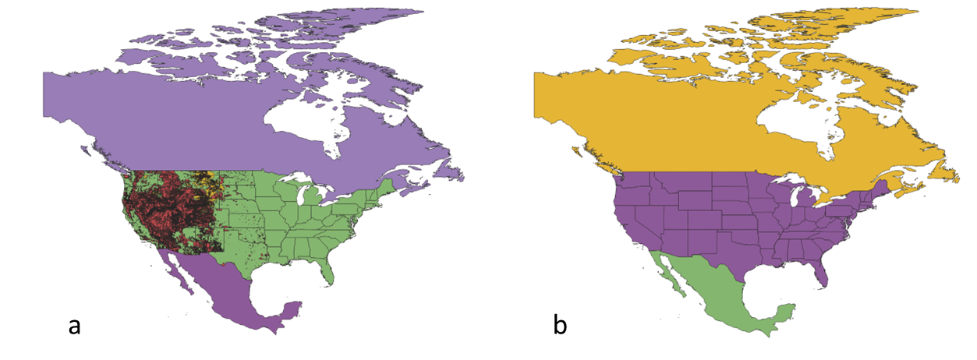

Figure . Shapefiles added to QGIS

6. QGIS assigns random colors to the layers so that yours may differ from Figure 2.

7. Save the QGIS project. Click on *Project – Save* from the menu bar. Navigate to where you want to save your work and save it as lab4. Note: A QGIS project is saved as a *.qgz file.

8. Rearrange the order of the layers to make them visible in the map view. Select the *Sage_grouse_current_distribution* layer in the *Layers Panel* and drag it to the top position. You will see a line as you drag this layer up the list. Next drag *Land_ownership* so that it is the second layer in the list. The correct order is shown in Figure 3. Right-click on the *Sage_grouse_current_distribution* layer in the *Layers Panel - Zoom to Layer(s).* The *Map Canvas* should show something similar to Figure 3.

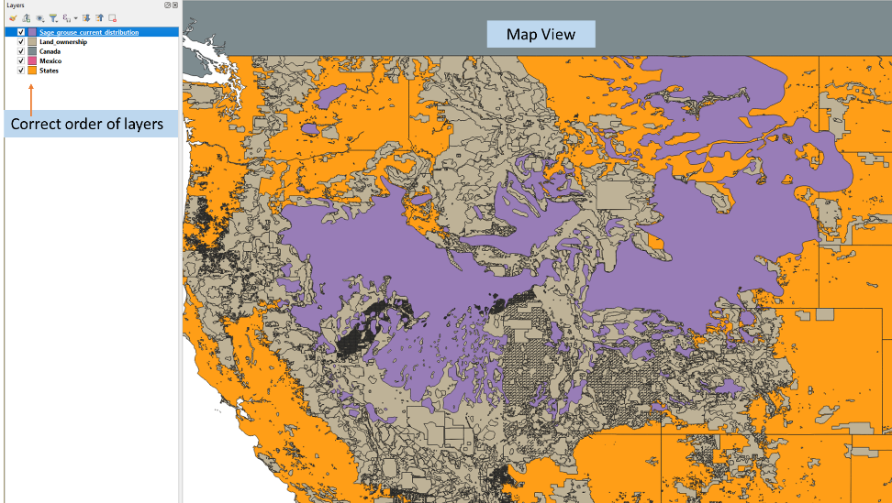

Figure . Layers reordered and Zoomed into Sage-grouse Range

Now all the data layers should be in the correct order. Typically, data layers will be organized with point data layers on top of the line layers on top of the polygons. Raster layers are usually placed at the bottom.

***Part 2 – Set the coordinate reference system (CRS)***

Let us now turn our attention to the coordinate reference system (CRS) for the map. A Coordinate Reference System (CRS) in QGIS is a method that associates numerical coordinates with a position on the surface of the Earth. It defines how the two-dimensional, projected map in your GIS relates to real places on the Earth. There are two different types of coordinate reference systems:

* Geographic Coordinate Systems
* Projected Coordinate Systems

The decision of which map projection and CRS to use depends on the regional extent of the area you want to work in, on the analysis you want to do, and often on the availability of data.

Each project you open in QGIS has a coordinate reference system associated with it, known as the project CRS. The project CRS determines how the data you add to a project is displayed on the map canvas.

1. Note that the lower right-hand corner of QGIS displays EPSG: 4269. The number 4269 is the EPSG (European Petroleum Search Group) code for the coordinate reference system (CRS) the map is currently in.



Figure . Project CRS

2. Click *Project – Properties* from the menu bar then select the *CRS* tab (Figure 5) or simply click on the EPSG code in the lower right-hand corner (Figure 4) to open the Project Properties.

window. The CRS of the current project is highlighted in the *Recently Used Coordinate Systems* section. If you can see more than one CRS listed, this indicates that the layers you added include more than one CRS. The window in the lower right shows the valid extents for the selected CRS (Figure 4).

Select EPSG:4269-NAD83, the detail tells you it is a geographic coordinate system using the NAD83 datum. The map shows it is a North American CRS. If you select EPSG:5070 – NAD/83/Conus Albers, you will see that this CRS is only for use in the Continental US (CONUS). The QGIS map canvas adopts the CRS of the first layer added, which in this case was Canada. The geographic unprojected CRS makes the CONUS look stretched and distorted. We will change the CRS of the map canvas so that it “looks correct”. Click *OK* to close the window.

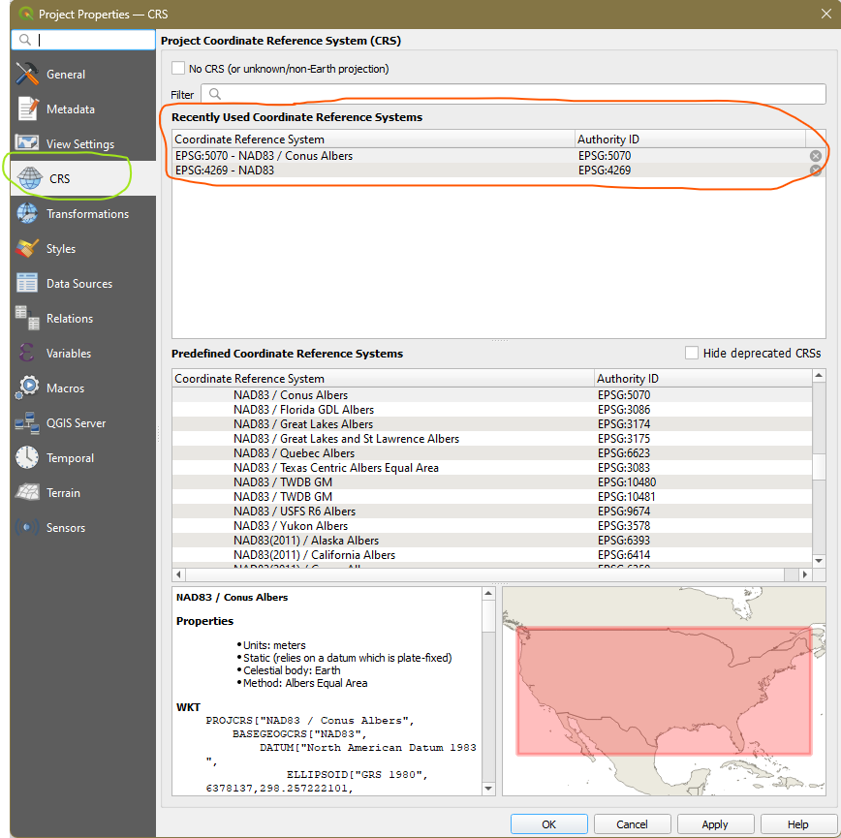

Figure . Project Properties - CRS tab

3. To determine which layers are in which CRS, simply hover the mouse over the layers in the Layer Panel (Figure 6). For example, the Sage_grouse_current_distribution and Land_ownership layers are in EPSG: 5070 while the rest are in EPSG: 4269. Since both of those layers are in EPSG:5070 projection, and the QGIS map is in EPSG:4269 (see Figure 4), they are both being projected on-the-fly into EPSG:4269.

Figure . CRS pop up information

4. We are going to set the map projection to EPSG:5070. Right-click on the Sage_grouse_current_distribution layer (or any layer that has EPSG:5070 projection) and choose *Layer CRS – Set Project CRS* (Figure 7). This will put the map view into the same projection as the Sage_grouse_current_distribution layer. Notice that the EPSG code in the lower right corner now reads 5070. This CRS gives the western US an appearance we are more used to. Any other map layers that are not on EPSG:5070 will now be reprojected on the fly into EPSG:5070.

Figure . Setting the Project CRS to that of a layer

Now you will change the layer names in the *Layers Panel.* The layer names match the names of the shapefiles by default. However, these names will appear in the legend. You should always change these to proper names which your map reading audience will understand.

5. Right-click on the Sage_grouse_current_distribution layer, and choose *Properties* to open the *Layer Properties* window (Figure 8). Choose the *Source* tab on the left, click the box next to *Layer name*, and change the name to *Sage-grouse Habitat*. Click OK to close the window.

You can also rename the layer by right-clicking on the *Layers Panel* then *Rename*. This will make the layer editable in the Layers Panel.

6. Change the other layers names as follows:

* Change Land ownership to Federal Land Ownership
* Change States to State Boundaries

7. Save your project

Figure . Changing the Layer Name

***Part 3 – Style Data Layers***

Now that you have set up your map, you will symbolize your layers and craft a well-designed map. Visually, you will want the landownership and the sage-grouse habitat to have the most weight. Canada and Mexico are there for reference but should fall to the background. You will make them both light gray.

1. Double-click on the Canada layer to open the Layer Properties window (this is a shortcut to open Layer Properties. Otherwise, you would right-click on the layer the *Properties*).

2. Click on *Symbology* tab

3. Select Simple fill (Figure 9)

4. Below the Symbol layer type are settings for both the fill and stroke (line) for this polygon. Click on the color bar to the right of *Fill color* (Figure 10) to open the *Select Fill Color* window.

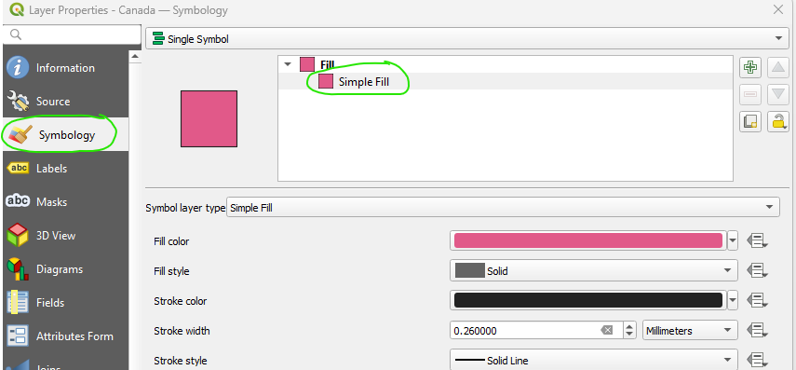

Figure . Simple Fill Settings

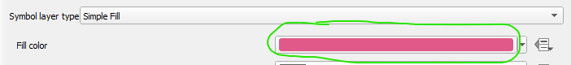

Figure . Click the encircled box to change the fill color

With the *Select Fill Color* window you can pick the existing colors in multitude of ways (Figure 11). To the left are four tabs that let you choose colors. To the right you can define colors based on (a) hue, saturation, and value (HSV), (b) red, blue, and green (RGB) values, and (c) HTML notation. There is also an *Opacity* slider.

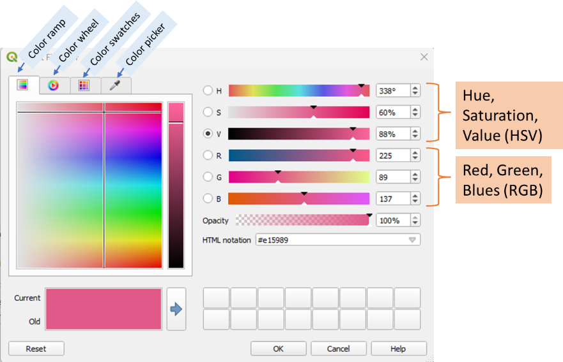

Figure . Color Picker Fill Settings

3. For Canada, set the color to H=0%, S=0%, V=90%. That should give you a gray color. Select OK to close the *Select Fill Color* window.

4. Back in the *Layer Properties* window, keep the default *Stroke style* to *Solid Line* but note the other options from the drop-down menu (Figure 12).

5. Click OK on the *Layer Properties* window to close and accept the symbology settings for the Canada layer.

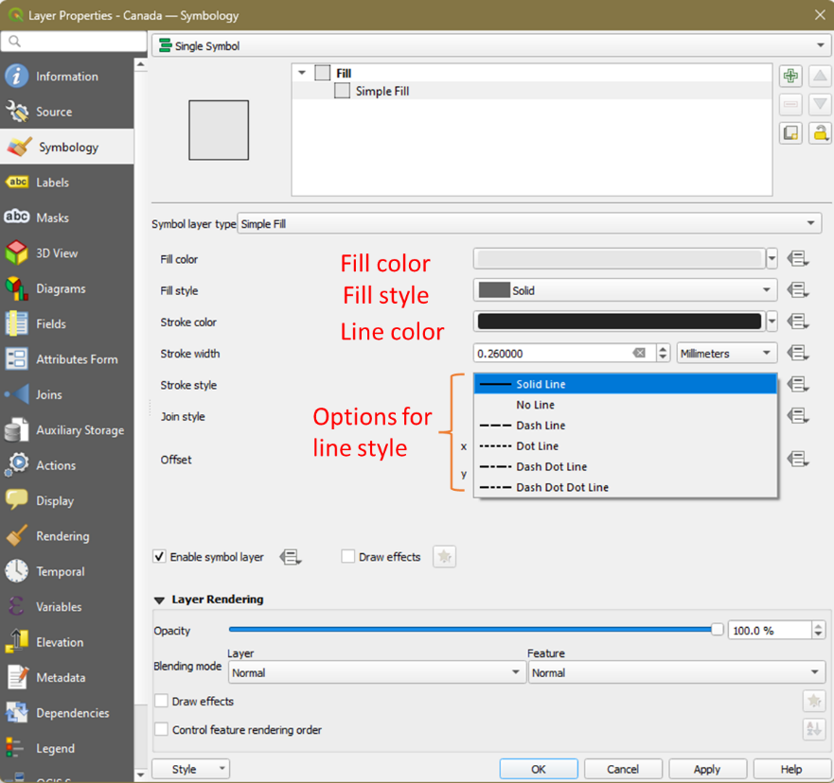

Figure . Symbology settings - choosing fill and line properties

6. Use the same symbology settings for the Mexico layer. You can repeat steps 1 to 5 or you can just copy Canada’s setting: Right-click on Canada layer and choose *Styles* – *Copy Styles* – *All Style Categories*. Right-click on Mexico and choose *Styles* – *Paste Styles* – *All Style Categories.*

7. Using the same workflow, give the State Boundaries a white fill. You will be able to find white in the *Color swatches* (see Figure 11) – *Standard colors* on the drop-down menu. Your map should look like in Figure 13.

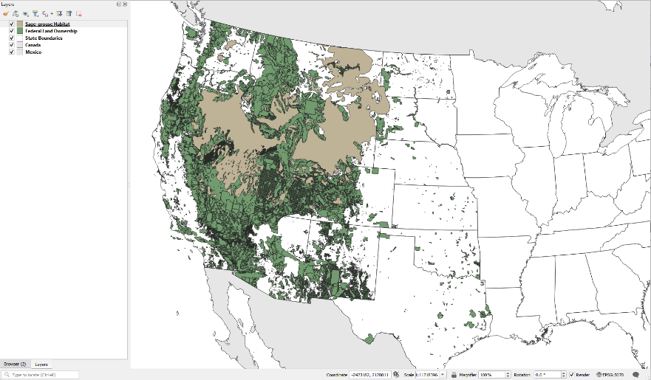

Figure . Mexico and Canada changed to gray and State Boundaries to white.

Now you will style the Federal Land Ownership layer. Instead of making the entire layer one color as default when you loaded the layer, you will assign color to each land management agency. We will use the *Layer Styling Panel* , found on the row icons atop the Layers Panel (Figure 14), to symbolize this layer. The information about which agency is managing each parcel is contained in the attribute table.

Figure . Opening the Layer Styling Panel

8. Right-click on the *Federal Land Ownership* layer in the Layers Panel and choose *Open* *Attribute Table* from the context menu. Notice that there are 13 columns of information regarding the federal lands. Can you find the one that contains the land manager? Close the attribute table.

9. Click the *Layer Styling Panel.* The panel will open on the right side of QGIS map canvas. Like all panels, this can be undocked to a free-floating panel or moved to a different docking position. On the top of the panel is a drop-down menu that allows you to choose the target layer. The target should be the *Federal Land Ownership* layer (Figure 15).

10. Below the target layer is a drop-down for render type (Figure 15). So far you have used the default Single Symbol renderer. Change this to *Categorized* renderer.

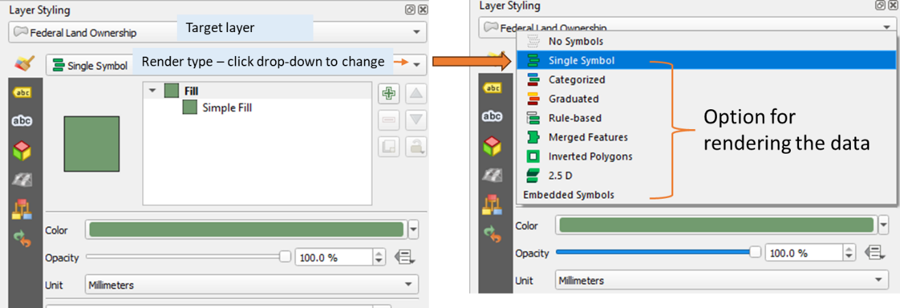

Figure . Changing the data rendering type

11. Choose the attribute column to symbolize the layer by, that is, the column containing the managing agencies. Choose AGBUR in the *Value* field by clicking the drop-down arrow. The column AGBUR is the one that contains the managing agency values.

12. Click the *Classify* button. This tells QGIS to sort through all the records in the attribute table and identify all the unique values in that column (Figure 16).

Figure . Setting up the categorical renderer

Now you can assign a specific color to each class by double-clicking on the color square. Notice that there is a symbol with no values. These are the parcels with *all other values* (or NULL) in the AGBUR field. They represent private and state holdings within the federal lands, Since you are just interested in depicting federal land ownership you will delete that symbol class.

13. Click *all other values* and then click *Delete* button  to remove that symbol. These parcels will not be included on the map.

We are now going to change the color of each land parcel following industry-specific standards. For example, people are used to seeing Forest Service (FS) land depicted in a certain shade of green.

14. To color BLM lands, double-click on the color patch left of BLM in the *Layer Styling* Panel. Select *Simple Fill.* Click on the *Fill color* patch to open the BLM > *Select Fill Color* window, and change the Red, Green, and Blue values to 254, 230, and 121, respectively (Figure 17). Click the go-back  button twice to return to the main layer in the *Layer Styling* Panel.

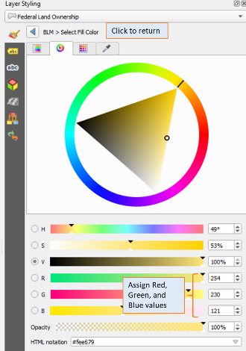

Figure . Setting the fill color

15. Use the values in table 1 to change the R,G,B colors for the remaining six land ownership classes.

Table 1. RGB values for remaining managing agencies

|  |  |  |  |
| --- | --- | --- | --- |
| **AGBUR** | **Red** | **Green** | **Blue** |
| BOR | 255 | 255 | 179 |
| DOD | 251 | 180 | 206 |
| FS | 179 | 222 | 105 |
| FWS | 127 | 204 | 167 |
| NPS | 177 | 137 | 193 |
| OTHER | 58 | 190 | 87 |

Finally, you do not want any border lines on these polygons. They are too visually distracting on such a complicated thematic polygon layer.

16. Go back to the main Layer Styling window with all land ownership classes visible (Figure 18). Uncheck all the layers by clicking in the white space outside the land ownership symbol classes.

17. Just below where the *Value* is specified, click the Symbol color patch (Figure 18). This will allow you to change the settings for all the classes. Select *Simple Fill* and change the *Stroke Style* to “No Line” (Figure 18). This will remove the outline for all polygons.

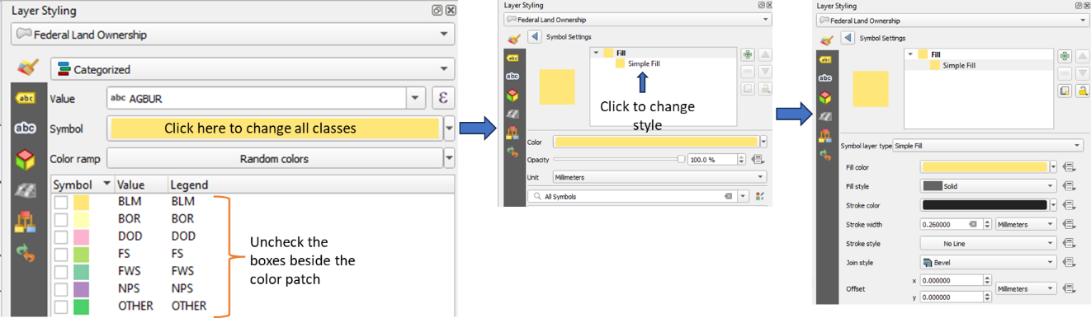

Figure . Changing the line style of all classes.

18. Click *Go back*  button to return to the main layer. Check all the boxes beside the color patch to make the classes visible again. Uncheck the *Sage-grouse Habitat* layer in the *Layers* Panel. Your map should now resemble Figure 19.

The last layer to work with is the *Sage-grouse Habitat*. You will style the Sage-grouse Habitat polygon with a cross-hatch pattern. This will allow the map reader to see land ownership data beneath.

19. On the Layers panel, check the box next to the color patch of the *Sage-grouse Habitat* layer to turn on its visibility.

20. On the *Layer Styling* panel, set the target layer to *Sage-grouse Habitat.*

Figure . Federal lands symbolized

21. Click on *Simple Fill* and change the *Symbol layer* type to *Line pattern fill*. This fills the polygonwith a line pattern and allows you to adjust the width, color, angle, and spacing.

22. Under *Fill.* Click *Line Pattern Fill* and change the spcing to 1.5. Click *Simple Line,* then click the color patch in *Color.* Change the color to RGB 170, 0, 255 (purple color). Go back  to *Layer Styling* panel.

23. Now we will add an outline to this polygon. To do this, you will add a new symbol element. Select the Fill and click the Add symbol layer button (Figure 20). *A Simple fill* symbol will be added (Figure 20).

24. Click *Simple Fill* and change the following:

* *Fill style* to *No Brus*h
* *Stroke color* to RGB 170, 0, 255 (same as the *Line Pattern Fill*)
* *Stroke width* to 0.46

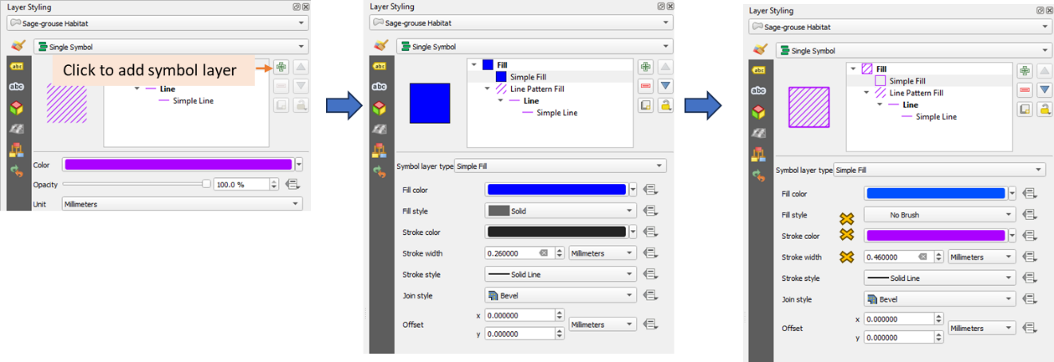

Figure . Adding and editing symbols

25. Right-click on the *Sage-grouse Habitat – Zoom to Layer(s)*. Your final map extent should look like in Figure 21

26. Save your project

Figure . Final Map Extent

*Part 4 – Compose a map deliverable*

1. You will produce a deliverable map following the procedure outline in Lab 3. You are free to style your map the way you want it (see example in Figure 22) but it has to have the following elements:

* Page properties:
  + Size: letter
  + Orientation: Lanscape
* Elements
  + Title: Sage-grouse Current Distribution (your choice of font and size)
  + Legend
  + Your name and date (your choice of font and size)
  + North Arrow
  + Scale bar

2. Export the map as an image (*.PNG, dpi = 300) and as a PDF file. Insert the image in your lab report and submit the pfd file along with your lab report on Canvas.

Figure . Example of final map deliverable